Bio

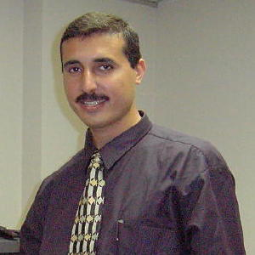
Name | Tarek Mohammad A. Eslim
Nationality | Palestinian / Jordanian
Address | Palestine
Tel.  | +970 8 2847 736
Fax. | +970 8 2847 736
Jawwal | +970 59 9529295
Email | tarek@altariq.ps

- B.Sc. & Master In Math’s. & Computer, Faculty of Science, Alexandria University, Egypt 1990, and Islamic University 2006, Excellent grade (A+).
- Founder and General Director of ALTARIQ Systems & Projects, special software house and IT solutions.
- Founder, Partner and general manager of my company [BIS&T], and the software department manager.
- Teaching in Gaza Islamic Univ. Faculty of Engineering.
- Partner & Founder of Palestinian Internet Company [www.p-i-s.com] (The largest Palestinian ISP)
- Worked in several companies in Egypt and Palestine
- Founder of the Diploma in Computer Program, Al-Azhar University 1996.
- Academic supervisor & Instructor; the Diploma Program; Al-Azhar University; Gaza 1996.
- Head of the Computer Department, Interior Ministry Palestinian Authority, 1994.

Through my professional life, I done and participated in several projects considered as milestones in the region, like:
- Palestinian Water Authority Automation 2006
- Billing & CIS for Gaza Electrical Distributing System 2005
- Palestinian Passport System, Ministry of Interior 1997
- Telephony Billing System for Ministry of Post & Telecom. 1996
- Pension Fund System, Gaza, 1996.
- Arab League Automation (Cairo 1993-1994)
- Ghana Government Automation (1992-1993)

Papers, Conferences & Seminars attended
- Paper in Regional IT R&D Center, Al-Zarqa Univ, Me & Dr. Ayman Abu Samra. 2001.
- Palestine representative in the USA IT International Visitors Program. Visited USA for cooperation with IT companies and organizations between USA and our Palestine. I visited a telecenter in Silicon Valley Sep 2002
- Network modeling and design, Dr Ali Soliman, British Telecom, Islamic university, May 1998.Software Industry development in Palestine, GCC general manager, Al-Azhar University, May 1997.
- Data communications, Dr. Ali Soliman, British Telecom, Islamic university, May 1998.
- Software Industry, Dr. G. Muler, Islamic universtiy, Oct 1997.
- Arab Computer Conference Cairo 1993.
- The first Arab Computer Conference in Cairo 1992 (Member of the organizers team).

